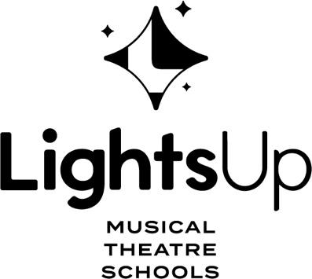

LIGHTS UP MUSICAL THEATRE AFTERSCHOOL AT MCKECHNIE ELEMENTARY

Sing Dance Act Shine! At Lights Up Afterschool, your child can experience the joys and benefits of musical theatre by taking part in our afterschool programs led by our talented and experienced Lights Up Musical Theatre Schools staff. These classes are a unique introduction to our weekend musical theatre programs and provide students with an enriching, rewarding, and most of all, fun afterschool activity right at the bell!

WINTER SHOW! TOY STORY
This Winter, we will be putting on a musical version of “Toy Story,” created for our afterschool students!
Students will be supervised from dismissal. No need to pick up your child until 5.15pm! Performance on the last day of classes for parents!
After School Fridays
JAN 12 - MAR. 15 (9 SESSIONS)
3:15-5:15 PM
GRADES: K to 7
Fee: $345* (*plus GST)
https://lightsuptheatre.ca/afterschool/mckechnie/

